**Study Rationale**

This experiment is a follow-up to Experiment 1 from the same project (<https://osf.io/6kj8t/>). In this experiment, we continue to investigate the effect of scene context on the functional set size. In Experiment 1, the scene was identical throughout the entire experiment. Thus, the relevant region of the scene was *perfectly* predictable, even before the scene was presented. Even if reaction times were not affected by the number of distractors in the irrelevant regions, it could have simply been due to spatial attention being allocated to the bottom half (relevant region) of the screen even before the search display was presented.

In addition, the irrelevant-region distractor (grey bird) was visually very different from the target (orange fish), while the relevant-region distractor (grey fish) was visually very similar to the target. Thus, the finding that irrelevant-region distractors did not affect reaction times could be due to the fact that these distractors were visually very different from the target and are quickly rejected, rather than due to guidance from scene context.

Lastly, although the distractors both had similar colors, the background against which they appeared had different colors that might have contributed to different evidence accumulation processes.

Thus, in this experiment, we sought to address these problems. To this end, we utilized a top-down view of a beach scene which was horizontally divided into a “sea” region and a “sand” region. This way, both the sand and sea regions could appear on either the top or bottom half of the scene. In addition, we utilized distractors (tortoises and turtles) that were both highly visually similar to the target (turtle). In addition, the irrelevant “sand” region will have the same color as the relevant “sea” region.

**Design**

The experiment will be almost identical to Experiment 1. The study will be a fully-within 4 (turtle setsize) x 4 (tortoise setsize) experiment. The setsizes would be: 0, 4, 8, and 16. It should be noted that the setsize refers to the number of distractors (e.g. there would be a total of 5 turtles in the 4-turtle condition). There would be 16 cells in total., with 50 trials per cell for a total of 800 cells. The entire experiment will be divided into 5 blocks of 160 trials each, with a rest period after each block. Within each block, there will be an equal number of conditions that will be presented in a random order. Both the tortoise and turtle lures will have a black shell and olive limbs, while the target turtle will have a green shell with brown limbs (Figure 1). All stimuli can be facing either the left or the right, with random rotation of ± 20 degrees, and will subtend approximately 1.328 x 0.986 degrees of visual angle.

The stimuli will be randomly presented on a 10 x 10 grid, with the constrain that turtles will only appear in the water, and tortoises will only appear on land. No stimulus will be presented in the borders of the grid, effectively making it an 8 x 8 grid. In addition, there will be a 40 x 40 (pixel) region in the center of the scene, where there are waves that separate the sand and the sea, where no stimuli will appear (Figure 1). Random x and y jitter of 15 pixels would also be added to each stimulus.

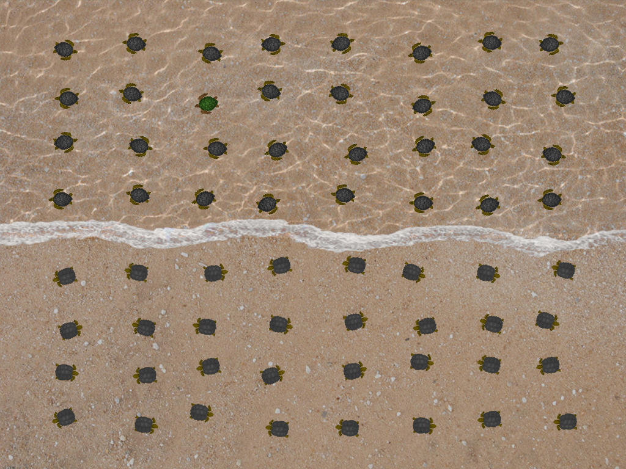

*Figure 1.* All possible locations of stimuli

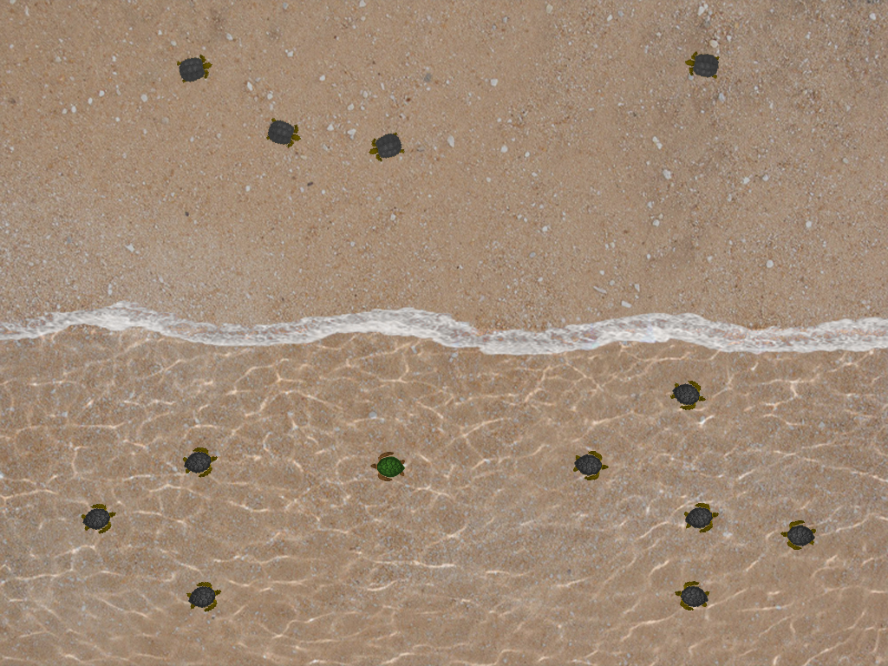

*Figure 2.* Example of a trial with set size 4 for the irrelevant region (tortoises) and set size 8 for the relevant region (turtles). Note that the set size refers only to the number of distractors.

Each trial will begin with a central white colored fixation cross against a black background that will be presented for a random duration between 800ms and 1000ms. The display will then be presented for a maximum of 2.5 seconds. Participants will be required to respond to the direction to which the target turtle is facing. Upon response, the display will terminate, and a blank screen will then be presented for a random duration between 1000ms and 1200ms. The next trial then begins.

Feedback, in the form of a loud beep, will be given for incorrect responses. No feedback will be given for correct responses. The experiment is expected to last around 45 minutes.

**Instructions and Procedure**

The following instructions will be presented to participants:

*Welcome!*

*You will be searching for a green turtle in a scene of black turtles and black tortoises.*

*Turtles will always be in the sea, while tortoises will always be on land.*

*Your task is to decide which direction the turtle is facing.*

*You will see examples of the turtle on the following screens.*

Upon acknowledging the instructions, participants will be shown the left-facing target and required to press the left arrow key to continue. After which, participants will be shown the right-facing target and required to press the right arrow key to continue. A practice block, with 8 trials, will then commence. All stimuli will be presented on a 22-inch cathode ray tube monitor with a refresh rate of 86Hz and a screen resolution of 1024 x 768 pixels.

**Exclusion criteria**

Before or during data collection:

1. If a researcher error occurs such as providing the participant with the wrong instructions or not properly setting up the experimental conditions (e.g. program or lighting conditions). Participants will be allowed to complete the study, but a note will be made in the experimental log sheet and the participant’s data will be excluded.
2. If the participant appears to be in an altered state due to being under the influence of a substance, or if they are extremely sleepy. A note will be made on the experimental log sheet and the participant’s data will be excluded.
3. If the participant is not following instructions, then they will be given a warning upon first notice and a note will be made on the experimental log sheet. The data from that participant will then be excluded.

After data collection:

1. Participants with error rates greater than 10% will be removed from analyses. This is the normal exclusion criteria used in many efficient search experiments, and is one that we have used previously.
2. Reaction times greater than 2000 will be assumed to be due to attentional lapses, and reaction times lesser than 200ms will be assumed to be due to anticipations (Wolfe, Palmer, & Horowitz, 2010).

**Analyses and hypotheses**

The dependent variables that will be collected are:

1. Reaction times
2. Accuracy

Since the main goal of this experiment is to examine whether items in irrelevant regions (i.e. tortoises on land while looking for turtles in the water) are processed in efficient search, our measure of interest is reaction times.

Logarithmic and linear slopes will be fitted to the reaction times for the relevant and irrelevant lures separately. We expect to see better logarithmic compared to linear fits (measured by both R2 and AIC values) at least for the relevant lures (turtles). This would extend our model to yet another new stimulus set (cf. Buetti et al., 2016; Wang, Buetti, & Lleras, 2017, Experiment 1 of this project).

If scene context influences efficient search, the number of tortoises on land (irrelevant region) should not affect reaction times to find the target turtle in the water.

If the entire search display is processed in efficient search regardless of scene context information, then the set size of the irrelevant region would affect reaction times. There could be one of two possibilities:

1. The irrelevant lures would add a logarithmic cost to search time just like the relevant lures (e.g., Buetti et al., 2016)
2. The irrelevant lures would be rejected en masse and add on a constant cost (i.e. not affected by set size e.g. Humphreys & Müller, 1993).

**Participants**

Participants will be recruited from the student population of the University of Illinois at Urbana-Champaign. They will receive either course credit or monetary compensation. Only participants who have normal color vision will be recruited for the study.

A Sequential Bayes Factors approach will be taken with regard to the sample size (Schönbrodt, Wagenmakers, Zehetleitner, & Perugini, 2017). Starting with a minimal number of 20 participants (Schönbrodt et al., 2017), we will continue data collection until the effect of the irrelevant lures reaches BF10 = 3 or BF10 = 1/3. This would constitute “moderate” evidence for the alternative or null hypothesis respectively (Jeffreys, 1961; Kass & Raftery, 1995).

**References**

Humphreys, G. W., & Müller, H. J. (1993). Search via Recursive Rejection (SERR): A connectionist model of visual search. *Cognitive Psychology*. http://doi.org/10.1006/cogp.1993.1002

Jeffreys, H. (1961). *Theory of probability.* Oxford University Press

Kass, R. E., & Raftery, A. E. (1995). Bayes factors. *Journal of the American Statistical Association*, *90*(430), 773–795.

Schönbrodt, F. D., Wagenmakers, E.-J., Zehetleitner, M., & Perugini, M. (2017). Sequential hypothesis testing with Bayes Factors: Efficiently testing mean differences. *Psychological Methods*, *22*(2), 322–339.

Wang, Z., Buetti, S., & Lleras, A. (2017). Predicting search performance in heterogeneous visual search scenes with real-world objects. *Collabra*, *3*(1), 6. http://doi.org/http://doi.org/10.1525/collabra.53

Wolfe, J. M., Palmer, E. M., & Horowitz, T. S. (2010). Reaction time distributions constrain models of visual search. *Vision Research*, *50*(14), 1304–1311. http://doi.org/10.1016/j.visres.2009.11.002